This is the Tri-Arrows / Logan Aluminum specification for Used Beverage Cans (UBC) in Bales and Biscuit Forms.
1. Definition
Used Beverage Cans (UBC) – Used aluminum cans (post-consumer) free of other scrap metals, foil, tin cans, food cans, steel cans, plastic bottles, paper, glass and other non-metallic items. All UBC scrap must be magnetically separated prior to baling regardless of Processing Origin and free of steel, lead, bottle caps, plastic cans and other plastic, glass, wood, dirt, grease, trash and other foreign substances. Aluminum items other than UBC are unacceptable and are grounds for rejection. Variations to this specification should be agreed between TAA and the seller prior to shipment and documented in the Purchase Order. Material thickness for UBC of all current types is <0.0200” max.
2. Purchase Order Contingency
Each purchase order or contract is contingent upon the supplier’s acceptance of these terms. Supplier acknowledges that delivery of any material to TAA / Logan shall be deemed acceptance of these terms, and agrees that any terms and conditions contained in a proposal, quotation, acknowledgement, acceptance, invoice, or other document of supplier which are different from or in addition to these terms and conditions shall not constitute a part of the purchase order and are hereby expressly rejected, and that no employee of TAA nor Logan is authorized to or may, waive nor modify these rights.
3. Supporting Documentation
Shipping documentation must accompany each load. The documentation must be either provided by the driver or affixed to the shipping container. The documentation must be accurate and clearly state the following:
- Purchase order number
- Appointment Number
- Bill of Lading number
- Material Classification
- Material Source (yard/origin)
- Items Shipped
- Piece Count of each material type
- Gross, tare weights of each material type
Incorrect/missing information on the shipment documentation may result in either a delay in unloading or in a rejection of the receipt of the material.
3.1 Split Loads
Documentation must support the material on the truck. The recommendation for loading split loads is to load the material type with the greatest quantity first. Then load the material type with the second greatest quantity next. Then the remainder of the material can be loaded. No more than 3 material types per load without prior approval.

4. Insurance
Each vendor selling scrap or metal to TAA / Logan shall have and maintain adequate minimum insurance coverage including but not limited to, general and product liability insurance coverage, protective of both TAA / Logan and supplier from any and all claims and liabilities for property damage, personal injury, death, and economic damage, that arise from the material and associated activities, hereunder, endorsed as required, at all times while conducting business with TAA / Logan.
5. Material Safety Data Sheet
Per the requirements of 29 CFR 1910.1200, the supplier, vendor, or importer must provide a Material Safety Data Sheet (MSDS) for the metal or scrap sold to TAA.
6. Types by Processing Origin
All UBC scrap must be designated by its Processing Origin. Failure to properly designate UBC Processing Origin is grounds for rejection. The hierarchy for “processing origin” is as follows, in order from 6.1 to 6.5.
6.1 UBC-MRF: UBC Originated from Municipal Recycle Facilities (any location)
6.2 UBC-Deposit: UBC originating from deposit collection programs in USA/CAN
6.3 UBC-D: All Other Domestic UBC originating inside USA or CANADA
6.4 UBC-M: Imported UBC originating from Mexico
6.5 UBC-I: Imported UBC originating from countries other than Mexico

*All Inbound scrap deliveries MUST include the origin location on the BOL provided*

7. UBC Bale Types
UBC is acceptable in Bale, HD Bale, and Biscuit form for all bulk density less than 55 lb/cubic ft. Briquettes/Bricks (ISRI designation TALDORK “Briquetted Aluminum UBC scrap”) with high bulk density >55 lb/cubic ft are NOT acceptable.

Table 7.1 Acceptable and Unacceptable UBC Bale Types and Bulk Density Values

Logan  Package Code | Industry Name | ISRI Name | BULK  DENSITY | Logan Bale/Bundle Size | Acceptable /  Not Accepted
Bale | Standard Bale | “TALDON” | 14-25 lb/ft³ | Volume >30 cubic ft each  Bale 24-40” x 30-52” x 40-72” | Acceptable
HD Bale | Hi Density Bale | n/a | 25-30 lb/ft³ | Volume >40 cubic ft each  Bale 24-40” x 30-52” x 40-72” | Acceptable
Biscuit | Biscuit-Densified | “TALDACK” | 35-55 lb/ft³ | Weight <50 lb per biscuit  Bale 41-44” x 51-54” x 54-65”  Biscuit 10-13”x10¼-20”x 6¼-9” | Acceptable
HD Briquette | Bricks, Briquettes | “TALDORK” | >55 lb/ft³ | Weight < 4,000 lb per Bale  Bale 24-40” x 30-52” x 40-72”  Brick A12-24” x B12-24” x 8-48” where A=B | NOT ACCEPTED

8. Moisture Deduction:
UBC should be dry; therefore, it is suggested that material not be stored or processed outside. A random sample will be pulled from each load to calculate a moisture percentage. Shipments with moisture in excess of 4% will be subject to a weight deduction or rejection. The deduction will equal the tested moisture percent minus 2%. See example below.
Table 8.1 Example of Moisture Deduction Calculation
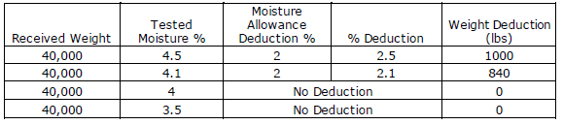
9. Contamination
The presence of the following items in a load of UBC material may be deemed reason for DOWNGRADE or REJECTION. See Section 11. Items include, but are not limited to:
a) Paper
b) Iron & Steel, brass, bronze and other nonferrous metals
c) Batteries
d) Rocks, dirt, sand and glass
e) Rubber, foil, pie pans, and wood
f) Insulated beverage containers
g) Excessive Moisture – Please note that loads with a moisture level greater than 4% of the load weight will be subject to a weight deduction (financial penalty) or rejection.
h) Plastic – This includes both free plastic and/or plastic added to UBC during the manufacturing process such as plastic label sleeves, plastic in bottle caps, plastic screw tops, nitrous widget balls, plastic nitrous tops, etc.
i) Food cans, steel cans, other non- beverage cans.
j) Oxidation.

10. Material Packaging Specifications
Improper packaging is grounds for rejection. TAA / Logan accepts Bales, high density Bales, and Biscuit forms of UBC in appropriate packaging as listed below. Failure to follow these packaging specifications is cause for downgrade or rejection.

10.1 Bales (TALDON)
See Table 7.1 for dimensions and bulk density.
Proper Banding:
- Wire Ties – minimum 4, maximum 10
  - Wire 10-gauge aluminum or
  - Wire 13-gauge steel
- Banding – minimum 4, maximum 6
  - Bands 5/8” x 0.020” steel or
  - Bands 5/8” x 0.036” plastic
- Bales should separate into sections when banding/wire is cut
- Bales of uniform size are preferred.
- Use of support sheets (cardboard, plastic, etc) is not acceptabl
10.2 HD Bales (no ISRI name)
See Table 7.1 for dimensions and bulk density.
Proper Banding:
- Wire Ties – minimum 4, maximum 10
  - Wire 10-gauge aluminum or
  - Wire 13-gauge steel
- Banding – minimum 4, maximum 6
  - Bands 5/8” x 0.020” steel or
  - Bands 5/8” x 0.036” plastic
- Bales should separate into sections when banding/wire is cut
- Bales of uniform size are preferred.
- Use of support sheets (cardboard, plastic, etc) is not acceptable.
10.3 Biscuits (TALDACK)
See Table 7.1 for dimensions and bulk density.
Proper Banding:
- Banding – banding slots in both directions (2 vertical, minimum 4 horizontal)
  - 5/8” x 0.020” steel or
  - 5/8” x 0.036” plastic
- Bales should separate into sections when banding/wire is cut
- Bales of uniform size are preferred.
- Use of support sheets (cardboard, plastic, etc) is not acceptable.
Per Table 7.1, bales of High Density Briquettes / Bricks >55 lb/ft3 (ISRI “Taldork”) are NOT accepted by TAA/Logan.
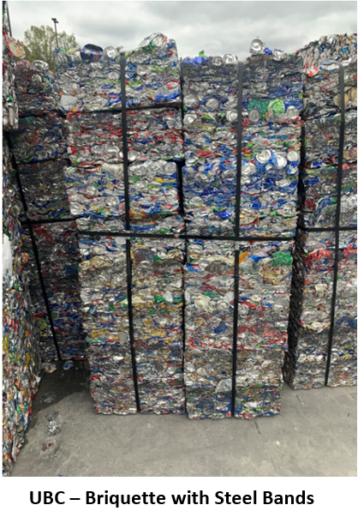
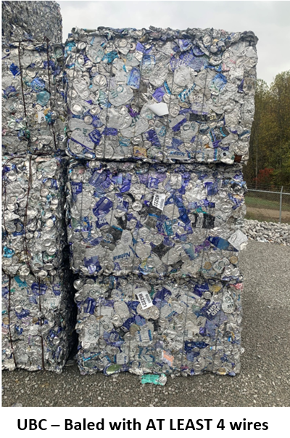
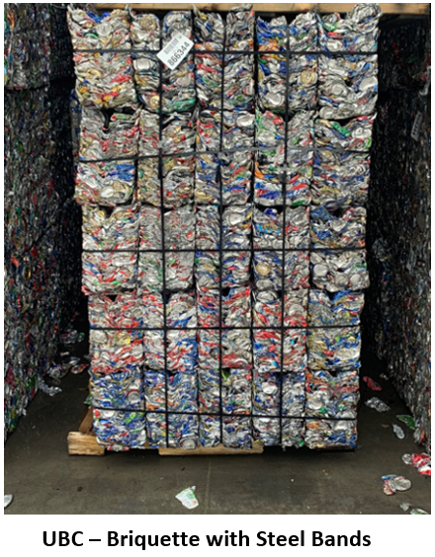
Examples of Proper Packaging
UBC Std Bale – at least 4 wires UBC Biscuit w/ Steel Bands UBC Biscuit w/ Steel Bands

Examples of Improper Packaging
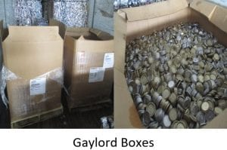
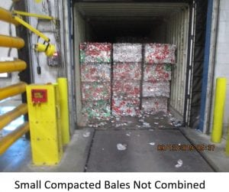

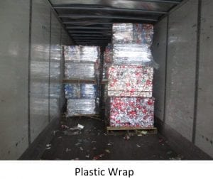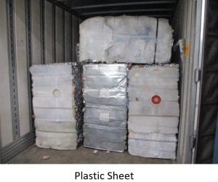

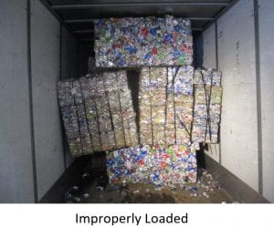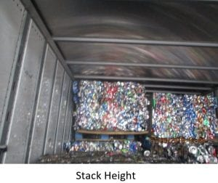

11. Material Downgrade/Rejection
Material that does not meet the requirements of this specification *OR* additional appropriate requirements set forth in the purchase order may be subject to Downgrade or Rejection.
11.1 Downgrades
If the material is deemed acceptable by an assignable downgrade of the material, the vendor has two options:
- Option 1 - The vendor can accept a downgrade of the material accompanied by an adjustment to the terms of the purchase of the material.
- Option 2 - Vendor can arrange to have the material picked up and removed from Logan property
Vendor has 48 hours after receipt to dispute a downgrade, after which, the load will be automatically accepted with the associated downgrade.
Examples of Downgrades
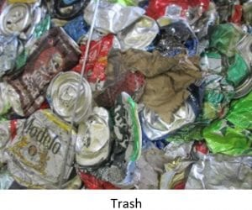
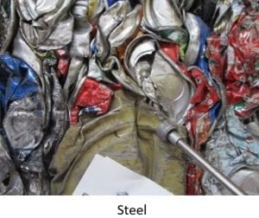
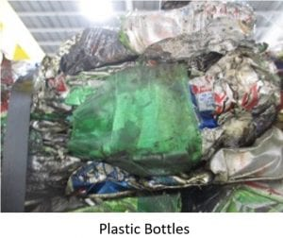
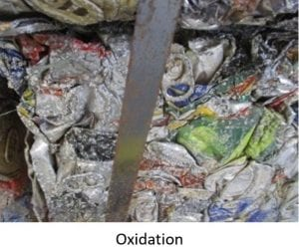
11.2 Rejections
If the material in a load is inspected and REJECTED based on the specification, purchase order, or other reasonable means then the Vendor will take the load back per the Commercial Agreement or Purchase Order with TAA. Due to space limitations, all rejected material must be removed as soon as possible. Material rejected at the time of delivery will automatically be reloaded on the truck it was delivered on. Material rejected and off-loaded will have two working days to be removed from Logan Aluminum. If the rejected material has not been removed in the allotted time, a truck will be scheduled for pickup and the material sent collect to the vender or location of the vendor’s choice. The vendor is responsible for costs of shipping and return for rejected materials.
11.3 Other Safety Items Deemed Reasons for Rejection
The presence of any amount of the following items in a load of UBC are hazardous to the customers and employees of Logan Aluminum and their Associates and as such are cause for immediate rejection and potential disqualification due to the threat they pose. Items include, but are not limited to:
a) Butane lighters - Butane lighters can have the strength of three sticks of dynamite when submerged into molten metal. More commonly found in UBC loads, and sometimes seen on the floor of the truck when unloading
b) Medical waste/hypodermic needles - Needles, surgical gloves, medical waste, etc. will not be accepted. Logan Aluminum is not set up to process/deal with this type of material
c) Ordinance, ammunition, or explosive subassemblies, live rounds, or scrap of any kind - Explosion potential for both shredding and melting operations. The assumption is, if there is one in the load there may be additional ones that are not visible and there is no guarantee that there are no live rounds.
d) Liquid storage and transfer vessels that can contain residual liquids (fuel/oil/antifreeze) – These tanks have both a potential closed container risk as well as the risk associated with flammable liquid/fumes. Material should be shredded and allow to be dried or verified that no fuel is present prior to melting or rejected.
e) Fertilizers/oxidizers - Fertilizer is an oxidizer. When an oxidizer (Nitrates/Sulfates etc.) are mixed with molten metal a violent reaction will occur. It takes very little material to create an explosion
f) Closed Containers – Closed containers can include but are not limited to oxygen tanks, fire extinguishers, crimped closed tubing, Freon tanks, aerosol cans, beer kegs, and baseball bats. Closed containers can develop extreme pressure when submerged in molten metal. Once the pressure reaches the burst limit of the vessel it can spray molten metal or present additional explosion potentials
g) Hazardous Chemicals – Hazardous chemicals such as PCB’s, pesticides, asbestos, etc. or loads that are labeled to include these materials will not be accepted
h) Free lead
i) Radioactive sources or Materials displaying Radioactive Warning Labels - Materials that fail to pass the gate radiation detector inspection process and any materials with a radioactive warning label will be rejected and returned following regulatory guidelines
j) Unidentifiable materials/substance
k) Infestation of the UBC by insects, rodents, etc.
l) Batteries (lead cell)
m) Excessive hydrocarbons

Examples of Rejections
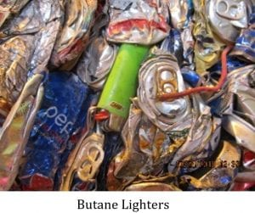
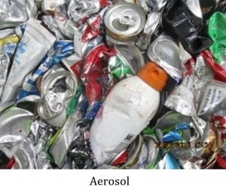

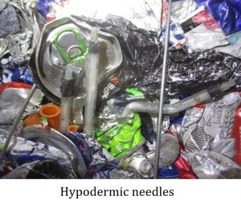
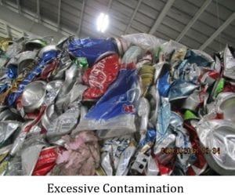

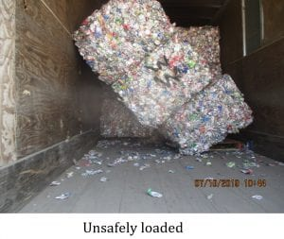
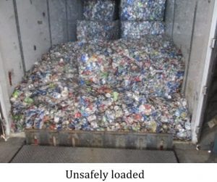

12. General Inspection
12.1 Inspection Report Documentation
Documentation of the inspection reports will be supplied in order to expedite settlement of issues such as weight discrepancies, downgrades and rejected loads.
12.2 Quality Verification
Each load will be inspected upon delivery. The material will be verified that it meets the criteria established within the purchase specification agreement. The material will be inspected for items such as excessive moisture, oil, dirt, garbage, plastic, glass, non-aluminum contaminants, aluminum fines, nitrates, sulfates, safety hazards, packaging issues, contamination of any kind. The results of the material inspection may be subject to a load rejection or if agreed upon, the material may be downgraded. Issues noted during inspection will be photographed and documented to the shipper.
During inspection, a determination will be made as to whether the material meets the purchase specification. If the load is determined to meet expectations, no deduction will be made regarding contamination.
Items that will be subject to immediate rejection of the entire load if found during the inspection include, but are not limited to: butane lighters, aerosol cans, hypodermic needles, live ammunition, explosives, gasoline, propane bottles or other gas cylinders or bottles, medical waste / infectious materials, radioactive material, PCB’s, mercury, asbestos, Freon, poisons, acids, fertilizer, rodents, excessive corrosion, oxidizers, flammable liquids, closed containers, crimped tubing, lead paint and other questionable items. The presence of these items poses a safety hazard to personnel and is not debatable.
12.3 Moisture Sampling Procedure
Sampling will be performed on all UBCs according to Logan Aluminum’s standard operating procedure 5.01.001.006. A SINGLE TEST will be performed upon delivery for determining moisture content. Material will be sampled under cover out of the elements. Loads with moisture levels exceeding an agreed upon threshold will automatically be put on hold. A load will be held for two working days for notification to the supplier. If in the allotted time a decision to accept or reject the test results has not been relayed to Logan Aluminum. The test results will be accepted, and the load will be identified in inventory as ready for production. Downgrades will be handled in accordance with Table 8.1 Example of Moisture Deduction Calculation.
12.4 Radioactive or Hazardous Material Detection
Material delivered to Logan Aluminum and found to be contaminated by radiation will be handled according to Logan policy. Any material triggering either of the two Logan radiation detectors will be rejected. Scrap, raw materials or packaging must not contain or be contaminated with hazardous material. TAA/Logan will have the right to revoke the acceptance of the material at any time. All costs and liability associated with radioactive material will be the responsibility of the supplier.
If radiation is present, the truck must remain on site while a US DOT SP-10656 form is completed by a Logan Aluminum ESS Representative. Upon completion, the form will be submitted to the necessary members of the US DOT.
An individual from the US DOT will then issue the permit US DOT SP-10656 for the carrier to return the load to the point of origin. The permit must be placed on the outside of the trailer. A copy of the US DOT SP-10656 permit will also be given to the driver in case of any damage caused to the original during transit.
Logan personnel will obtain the necessary permit for the shipment to leave plant-site, ensuring that regulatory requirements for the state of Kentucky have been met.
Once the shipment has left the plant, Logan/TAA is no longer liable, and it is the full responsibility of the carrier/supplier to meet any other regulatory requirements imposed by other states.

13. Trucks – Expectations and Procedures
13.1 Prep
Drivers must exit the cab, give their keys to Logan personnel, and chock the wheels of their trailer.
13.2 Driver Safety
Driver must (a) stay in an area designated by Logan personnel and (b) wear “approved PPE” at all times.
Approved PPE: Safety Glasses, Hard Hat, Long Pants, Long Sleeve Shirt, Closed Toed Shoes, and High Visibility Clothing. If any of this is not worn when arriving at any dock, it will result in automatic rejection of the LOAD.
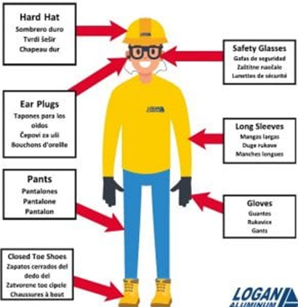

13.3 Process for Truck Delivery
- Drivers must check in at Truck Processing with correct unload number and paperwork upon arrival.
- Drivers for all Inbound Deliveries to Logan Aluminum will leave their Driver’s License at the Gatehouse upon check in. The Driver’s License will be returned once the trucks have been correctly out-processed.
- Truck drivers will be instructed by Truck Processing Attendants of plant rules and required PPE. After being checked-in drivers will be sent to the truck staging area to wait for unloading.
- Truck drivers will wait at staging area with load secured. Operators will direct drivers to the designated area for unloading.
- Drivers are required to wear proper PPE when out of truck unstrapping load.
- If driver must get on trailer to unstrap load, safety rails must be attached to trailer. Safety rails are located at Metal Control, Hotmill unloading area, and Tarping areas.
- All drivers must chock the wheels of their trailer, before the unloading operator will start unloading/loading process.
- All drivers must give ignition key(s) to the unloading operator who will maintain possession of the key(s) until the unloading/loading process has been completed.
- Forklift operator will not start unloading trailer until all straps and/or chains are rolled up and/or put away.
- All drivers and passengers must remain OUT OF THEIR TRUCK and stay in the designated waiting areas provided by Logan Aluminum until the unloading/loading process has been completed.
- Absolutely NO cans, bottles, or butane lighters allowed onsite.
- All drivers are responsible for cleaning/sweeping out their own trailers into designated area provided by Logan Aluminum.
- No one other than Logan Aluminum personnel allowed on the dock areas at any time.
- When unloading is complete driver will be instructed how to exit to the outbound scales.
- ANY INDIVIDUALS THAT DO NOT FOLLOW LOGAN ALUMINUM SAFETY REQUIREMENTS WILL BE REQUESTED TO LEAVE THE PROPERTY IMMEDIATELY.
13.4 Van Trailer - Expectations for Vans During Delivery
- The minimum height requirement is 105 inches.
- All vans must have floors in good condition. Any vans found to have unsafe floor conditions will not be unloaded.
- Material must be braced or loaded in a manner to prevent material shifting. If the material has shifted it will not be unloaded if determined to be unsafe to the operator or damage to the trailer may occur.
- Sufficient spacing must be maintained between the material and the roof/sides of the trailer. Material packed or wedged into the trailer will not be unloaded unless the trucking company or driver signs a waiver releasing Logan and Logan personnel of all liability.
- Trucks must remain in line near the truck scale until called for unloading. Trucks must not proceed to the unloading area without permission of the Logan unloading personnel.
- Drivers must follow all safety rules communicated to them when at the gatehouse. Drivers must stay with their truck. Drivers may enter the Recycle Receiving office but must not enter any production areas.
- Dunnage must not be left at Logan and must leave with the truck.
- Logan personnel will not be responsible for sweeping out trailers.

